1. Purpose:

Say you want to meet your friend at a restaurant. To send the link to the directions you would have to open a web browser, find the location, copy the link, and send it to your friend. Or alternatively open your map application and have to find the share link button which is usually not super easy to find. Whereas, with this application you would choose your friend that you want to meet and chose the location that you would like to send them.

1. Research:

To research this project, I did a lot of reading up on building applications using Android studio, and Java based programming. Also, I looked into how to implement the Google Maps API to be able to implement a map. I had some prior knowledge of Android application programming, so I used old notes and projects as a reference while I was getting started.

1. Languages, Software, and Hardware:
   1. Languages:
      1. Java
   2. Software:
      1. Android Studio
      2. Android Virtual Device
   3. Hardware:
      1. A friend’s Google Pixel 4
2. Requirements:

To be able to have a running application that satisfies the purpose of the project.

1. Implementation Description and Explanation:

* Home Page: The first step in the flow of the application is shown in Fig 1. this figure shows a list of the users list of contacts. To implement this, I used the built in API that Android Studio has that allowed me to have a loop to populate the contacts list.
* The next step in the flow of the application is shown in Fig 2. this figure shows the map that is presented to the user after they have chosen their desired contact. To implement this, I used the Google Maps API that is custom to Android Studio. The API allows me to present the user with a map with the user's current location and a search bar.
* The next step in the flow of the application is shown in Fig 3. this figure shows the Google Maps directions to the location that the user has chosen. With a success message telling the user that the text message was sent to the desired contact. Using the same Google Maps API, I used the location the user chose and put that into a link that opens with the directions to get to the chosen location. Also, to implement this I used another built in Android API that allows me to choose a message to send to a phone number, so using this I send the chosen contact the same link that the user’s screen is populated with.

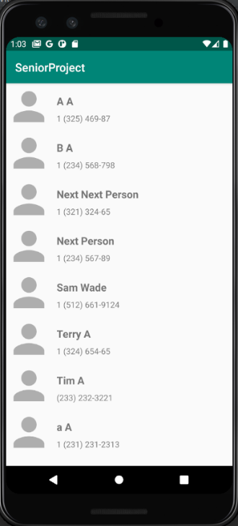 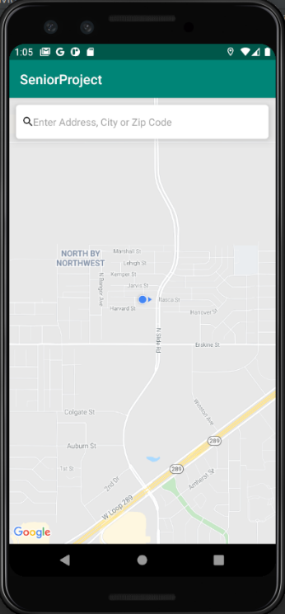 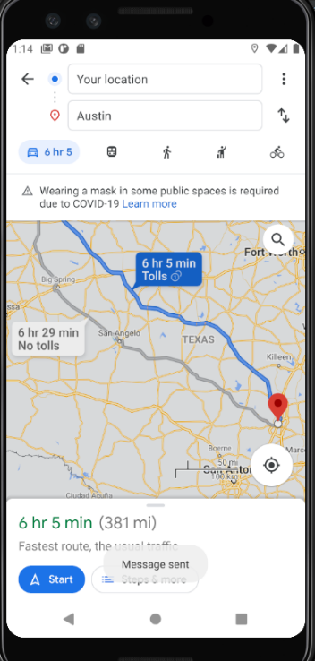

Fig 1. Home Screen Fig 2. Map Fig 3. Success Map

1. Test Plan and Results:

To test the project, I had a lot of different console outputs that would tell me the chosen contact, current location of the user, the location that the user has chosen, and whether the correct message was being sent to the contact. There was not a lot of options for me in the way of unit testing, so I feel like this was the best route to test and debug the program.

1. Challenges:

Learning Android Studio:

As I said previously, I have worked with Android Studio previously, but that was quite some time ago. There was a bit of a learning curve in the earlier parts of the project, but after some more practice by the end of the project I was feeling fairly confident with Android Studio.

Google Maps API:

Getting the Google Maps API set up in the beginning was I think one of the hardest parts of the project, since I have not worked with any outside APIs with Android Studio before this project.

AVD (Android Virtual Devices):

Pretty similar to the other two challenges, learning how to get the virtual device up and running was difficult in the beginning, but after learning how to set everything up right I was able to have them it and running.

1. Future Enhancements:

* Search Bar:

The current search bar just allows the user to type in a location, I would like to add an autofill option that gives the user more options for locations.

* Map:

Currently the map only shows an icon with the user’s current location and a map of the streets currently around them. I would like to have nearby restaurants and stores populate the map.

* Multiple Contacts:

Right now, the application only allows the user to choose one contact to send the contact too, but if the user wants to send the location to a group of people at the moment they would have to open the app multiple times.

* Better UI:

I would like to make the home screen with the contacts list more appealing. For example, show the contacts personal image that is saved in the user’s phone

1. Presentation Slides: https://github.com/samwade240/SeniorProject/blob/main/Senior%20Project%20Presentation.pptx